Proposal document

Jordi van Ditmar student number: 10875875

In this document, a proposal for an android app is done. The app, as of yet called ‘Friendly guess who?’ is in essence a digitalization of the classic game ‘guess who?’, but will be played with mutual Facebook friends instead of made up people. The game will be playable on either one or two devices. The app will basically be a representation of the classic game’s playing board. For the app Facebook’s API has to be used, next to that no external sources are necessary.

# Introduction

In the game ‘guess who?’, two players pick a card from a set of cards with fictional cartoon people on them (usually choice out of 24 cards). They then take turns, asking ‘yes or no’ questions to each other. Goal of the game is to be the first one to determine which card the opponent has selected.

In the app, the main idea of this game will be present. A few things will be significantly different, though. The most important change being that the set of people to choose from will not be fictional cartoony images, but a player’s actual Facebook friends. Because of this, more in-depth questions can be asked, since the players don’t only know what the people look like, but also their character, history, funny facts etc.

# What will the app look like?

The first screen you’ll be prompted with will be a log on screen (see figure 1), as you’ll need to log onto your Facebook account to get to a list of your friends. Then, you’ll see a menu where from you can start the game (a choice can be made between playing on one or two devices), read the rules and where there’s room for some future expansion.

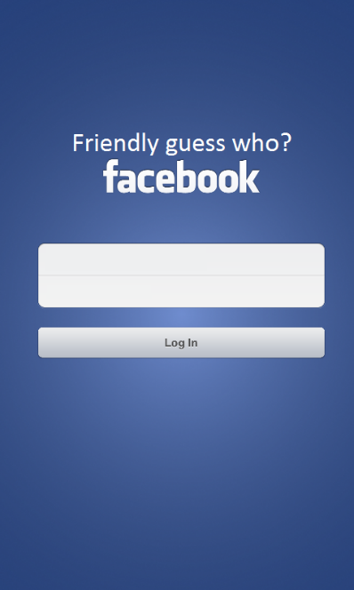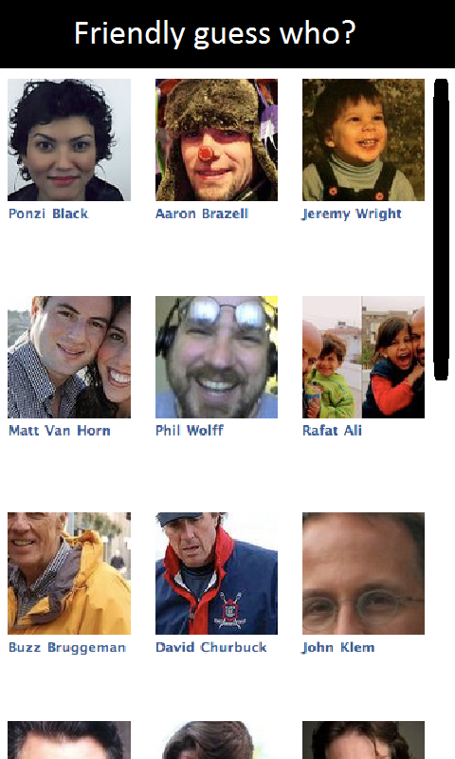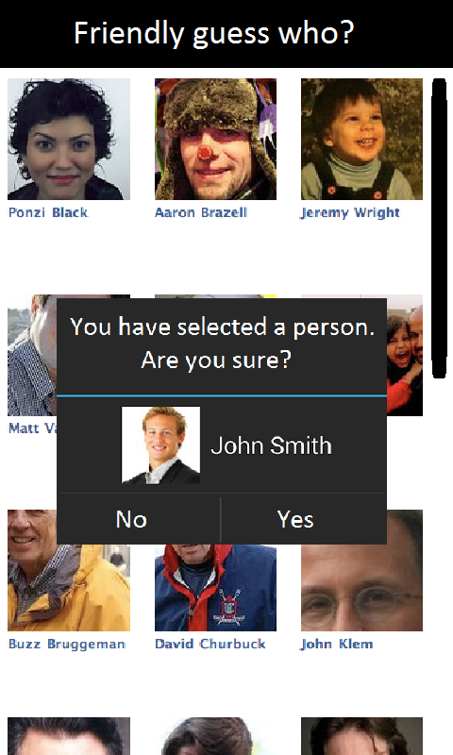

Figure 3, selection confirmation

Figure 2, character selection

Figure 1, login screen example

Upon pressing the ‘start game’ button, a selection has to be made between playing on one or two devices. Playing on two devices will mean that the other player also has opened the app, logged on and selected the ‘two devices’ option. Both players will have to select the friend they are playing with (so the pool of mutual friends can be loaded, of which 24 will be selected to play with) (see figures 2 and 3). From this pool of mutual friends, they have to select the person they want to be in-game (again, see figures 2 and 3, the player selection and character selection screens will be very similar), and then the game begins.

The game will be played in a conventional manner, where the two players take turns asking each other questions, and the first one to guess the right person wins (guessing a wrong person will let you lose automatically). For an example of what the gameplay will look like, see figure 4. Every turn, the player can select people to be crossed off the list and then press ‘next turn’ to actually remove them from the screen (this way the amount of turns can be counted, a sound will be played upon pressing the next turn button to avoid cheating). Note that, although connectivity between the devices will make the app more intuitive/interactive, it is not necessary for the core working of the game. As such, being able to connect the devices is something that will be looked into, but it’s not on the high-priority list.

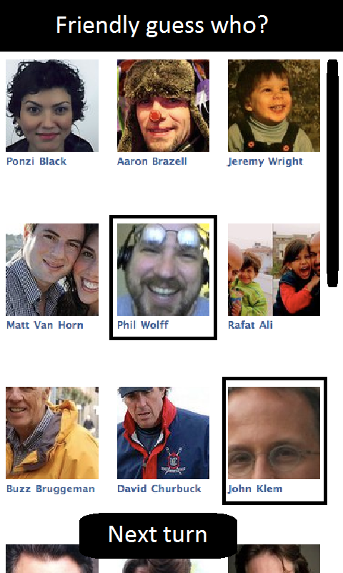

Figure 4, gameplay example

Playing on one device will result in a less conventional version of the game, where the players don’t take turns asking questions. Instead, two rounds of the game are played: one round where player 1 asks questions about player 2’s identity, and one round where it’s the other way round. In the end, the player who needed the smallest amount of questions to get to the answer, wins. In this game-mode, guessing the wrong person will result in a penalty of 3 turns.

# Necessities for the app

An obvious source of data for this app is Facebook. The mutual friends of the two players have to be loaded. Luckily, Facebook has a neat API and a large community using it, so no problems in retrieving this data arise yet. Aside from the Facebook friends, the app is completely standalone in the sense that nothing else is needed to play the game. The game relies completely on the real-life player to player interaction, and the app only needs to function as the games board. This will make the implementation of the app’s features fairly straightforward.

# Programming process

Finally, a description of the most logical programming process will be given here. The app can be decomposed into small parts, which can be implemented and tested one by one. These parts, in the most logical implementation order, are listed below:

* The logon screen activity
* The code handling the retrieval of Facebook’s data
* The ‘friend to play with’ selection activity
* The game’s main menu activity
* An activity where the ‘pool of friends’ can be viewed and possibly altered
* An activity where the player(s) can pick who they are in-game
* The gameplay activity for a game on one device
* The gameplay activity for a game on two devices
* An activity that is shown after a game is finished